Date Time

This ambulatory pathway is to be used for patients with a hypoglycaemic attack. Patients can be added to the pathway prior to or during admission. It does not replace the medical notes for the patient episode.

Capillary blood glucose on presentation: CBG now:

Exclusion criteria (exclude if any) |  | Exclusion criteria (relative) | Tick
>2 hypoglycaemic attacks in last week |  | Alone at home consider admission to CD Ward
Untreated underlying cause
Patient taking long-acting sulphonylurea |  | Not known to be diabetic

Initial Investigations
Ensure that FBC, UE and laboratory glucose are sent and reviewed.

Treatment
Use the treatment flow-chart on the following page.

Monitoring
Monitor patients for 90 minutes, checking CBG, BP, Pulse and patient’s condition every 30 minutes.
Time (minutes) | Capillary blood glucose (CBG) | Patient well (Y/N) | BP | Pulse
0
30
60
90

Discharge decision
Patient can be discharged if all are met: | Tick
Patient eating and drinking well
Patient has fully recovered after treatment
Patient has a good understanding of management
Cause has been identified and addressed
Lead Clinician agrees to discharge if relative exclusions

Communication/Follow-up
1. Create EDS or other discharge note and send to GP with copy to patient and copy to DM nurses
2. Refer patient to the Diabetic Nurse in the GP practice or consider referral to Specialist
3. Provide the patient with an information leaflet/patient passport and copy of the EDS
4. File this paperwork in the patients notes

RAC doctor/GP responsible for patient:

I confirm that I have followed the patient pathway above and completed the steps required

Signed: Grade: Contact details:

Treatment protocol

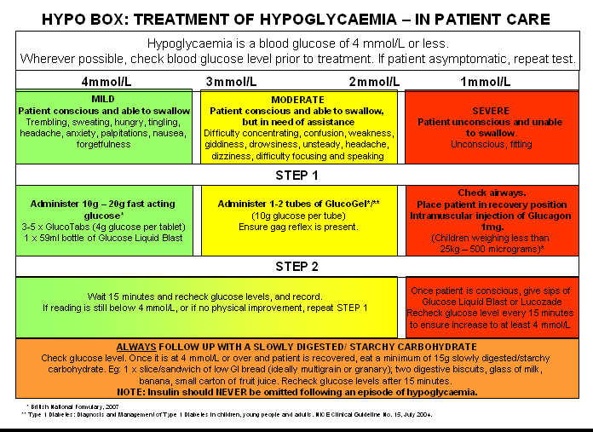Treatment should follow the protocol below which can be found in all SaSH hypoboxes.

Further advice

Take medical history and perform examination. You should establish if the patient is a known diabetic. Hypoglycaemia can be explained by factors such as decreased oral intake, excess sulphonylurea/ insulin administration or intercurrent illness (infection, MI, renal failure, hypoadrenalism).

• Sulphonylurea: decrease dose by 25-50% and advise patients to have doses reviewed in 24-48 hrs.
If on long acting sulphonylurea medications (eg glibenclamide) consider changing to short acting
(eg gliclazide).
• Insulin: decrease doses by 2-4 units each and advise to have dose reviewed in next 24-48 hours (by
GP/ diabetic specialist nurse/ diabetic doctor).

In un-explained hypoglycaemia consider sending serum save for insulin and c-peptide on hypoglycaemic sample of blood (pre-treatment).

